 **FACULTY OF SCIENCE AND**

**ENGINEERING SEMESTER 2, 2018**

**IAB330: Mobile App Development**

**Assignment 3: App Prototype** **Due Date: Friday, 2ndNov 2018, 11:59 pm**

**Assignment submission as a team through Blackboard**

**Weight: 50%**

You must sign below. By signing this form, you agree to the following:

We declare that all of the work submitted for this assignment is our own

original work except for material that is explicitly referenced and for which we have permission, or which is freely available (and also referenced)

The assignment shall be conducted in a team of 3-4 students, each team member must sign, as it is a formal agreement that represents that everyone is contributing to the whole assignment.

|  |  |  |
| --- | --- | --- |
|  | **Team Member Detail** | **s** |
| **Student Number** | **Student Name** | **Signature** |
| N10000569 | Sean O'Connell |  |

Contents

User Stories 3

Featured User Stories 3

MVP Implementation 3

User Interface 4

Opening Pages 4

Guest Pages 5

Host Pages 5

Software Architecture 5

Testing and Quality Assurance Strategy 6

Reflection on Learning 6

# User Stories

### Featured User Stories

|  |  |  |
| --- | --- | --- |
| Story ID | User Story | Status |
| 1 | As a user, I want to register an account so that I can use the system. | Incomplete |
| 2 | As a user, I want to sign into my account so that I can use the system with more control and customisability. | Complete |
| 3 | As a user, I want to create a new host instance so that I can create and control events. | Complete |
| 4 | As a user, I want to create a guest host instance so that I can join and vote for songs in events. | Complete |
| 5 | As a host, I want to create a set list so that I can allow people to vote for the songs at an event. | Incomplete |
| 6 | As a host, I want to create an event so that I can give the audience more control of the upcoming songs at an event. | Complete |
| 7 | As a guest, I want to find an event so that I can vote for my favourite songs at events. | Incomplete |
| 8 | As a guest, I want to join an event so that I can make my experience better with the host playing my favourite songs. | Complete |
| 9 | As a host, I want to see how much time I have left in the event so that I can plan the amount of upcoming songs and to see if I can fit an upcoming song into the remaining time. | Incomplete |
| 10 | As a guest, I want to vote on songs so that I can enjoy the experience at the event. | Incomplete |

### MVP Implementation

The completion of the MVP wasn’t successful in this iteration. However, the key features are outlined in the current version. The main reasons as to why the these aren’t completed as they require a backend database for holding the sort of information for dynamic use of the application. The implementation of these user stories will be completed using an Azure mobile backend. This extra functionality would complete all the user stories and allow for a more complete application. Unfortunately, I ran out of time to implement this and thus properly complete all the user stories.

# User Interface

### Opening Pages

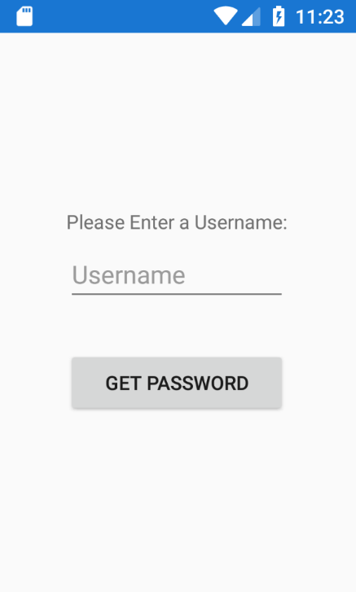

These pages have been grouped together as they all demonstrate the importance of user account control in the application.

The first page is the login page that allows user login and take the user to an instance page that redirects them to a guest or a host instance.

The third and fourth pages demonstrate user registration and user password retrieval. These aren’t fully functional as they require a database backend to save and control the user information.

### Guest Pages

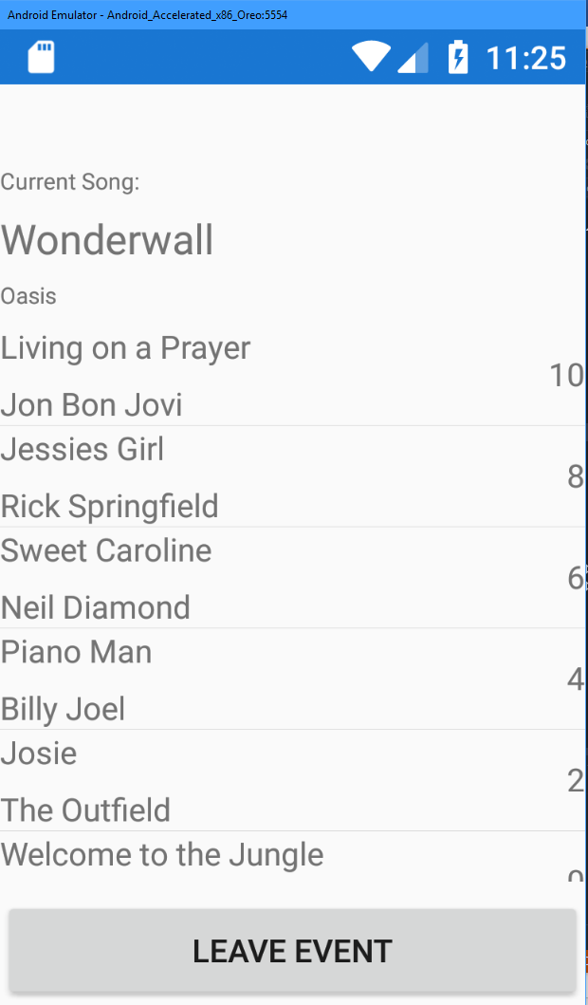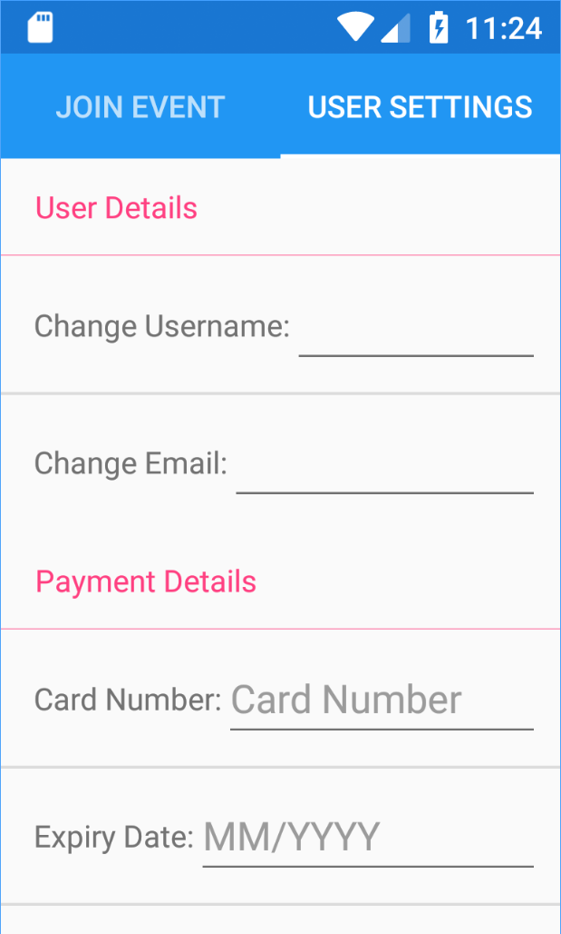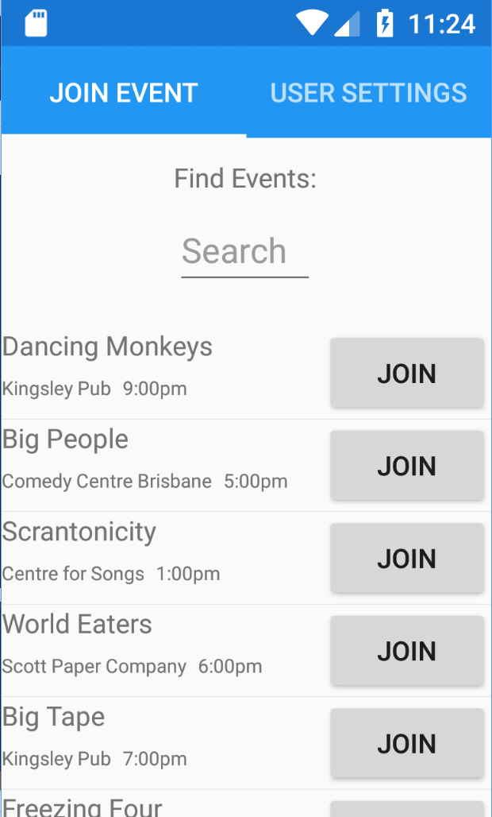

These pages are the available pages to any user starting a guest instance. This instnace allows the user to join an event, make an input on that event and change the user information. These are all important to the guest experience.

### Host Pages

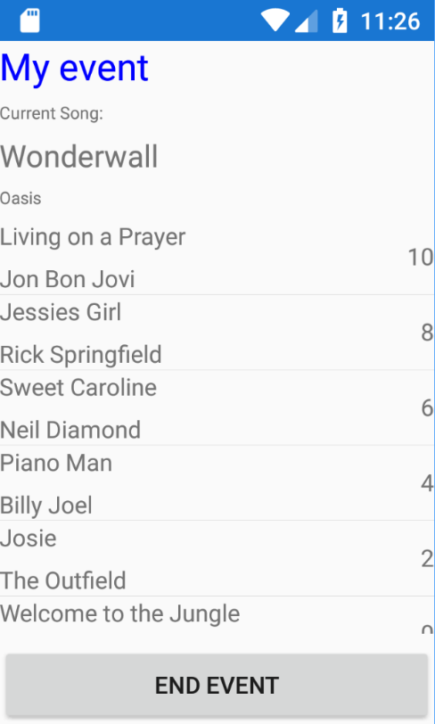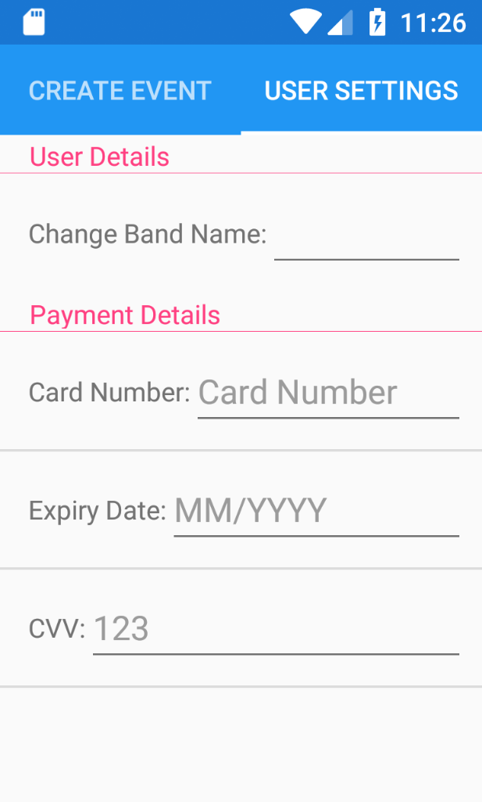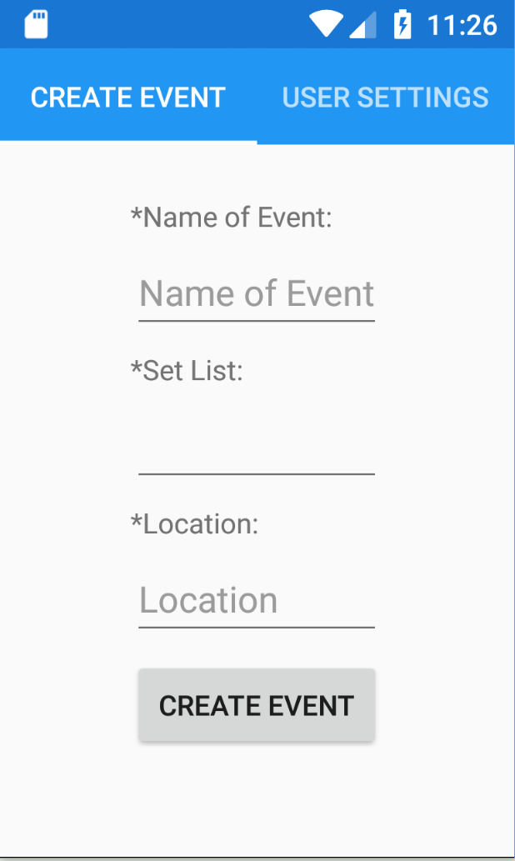

These pages highlight the access that the host has to the event creation and control. Admittedly, there isn’t much control in this MVP. However, the application does enlighten to the fact that the host can make these events with great functionality.

# Software Architecture

The architecture changed over the period of implementation. It changed due to the struggles of implementing the database and getting the Spotify API working with the application backend. The Azure backend

Provide a diagram (e.g. UML) of your entire software architecture.

Discuss how your architecture changed/evolved compared to the one proposed in Assignment 1 during the implementation process.

Explain the reasons behind the changes and what factors influenced the evolution of your software architecture.

# Testing and Quality Assurance Strategy

Explain which testing methods you used and how you applied them in order to assure the quality of your app.

# Reflection on Learning

Summarize the faced challenges and difficulties and you resolved them.

Focus on technical, project management, design and/or teamwork challenges.

Elaborate on what you learned during this semester as a team.